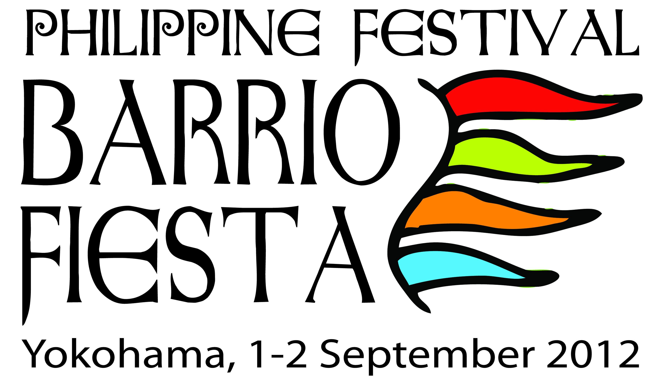
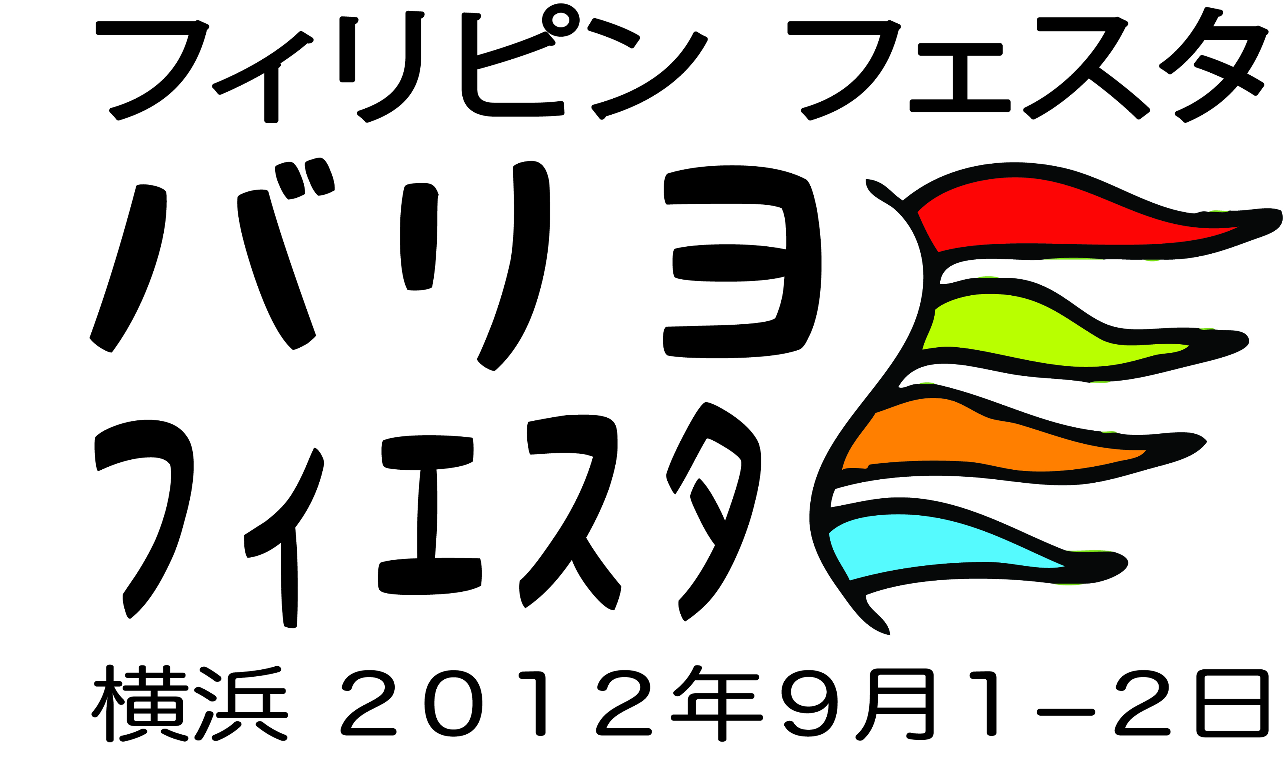
A Project of the Filipino Community in Japan
With the Support of
the Philippine Embassy in Tokyo

_________________________________________________________________________
PHILIPPINE FESTIVAL
BARRIO FIESTA
Yamashita Park, Yokohama
1-2 September 2012

. GUIDELINES FOR BOOTH RENTAL AND USE
- The festival shall be open to the public between the following hours:
      - 10.00 hrs until 18.00 hrs on Saturday 1 September
      - 10.00 hrs until 18.00 hrs on Sunday 2 September

- Booth locators/renters access to Yamashita Park to set up shall be from
- 7.00hrs until 9.00hrs on Saturday 1 September.
- Clean up will start at 1700hrs on Sunday 2 September

- Acceptance of booth renters shall be on a first-come-first-served basis. Those who apply and pay early shall be given the privilege to choose their preferred booth location at the venue. Payments made for booth rental are non-refundable. Deadline for submission of application and remittance of payment shall be 06 August 2012.

- All commercial booths (i.e. banks, remittance companies, real estate business) shall present/highlight Filipino culture, tourism (e.g. condominiums as retirement havens for elderly Japanese, or if units are in scenic places in the Philippines, etc) and corporate social responsibility (e.g. assistance to Tohoku region, scholarships to poor but deserving children, etc) as part of their promotional activity.

- All food booths shall secure a short-term Restaurant Permit valid for 1 day to 5 months on or before 10 August 2012 from Nakaku Public Health Department, Kanagawa Prefecture; Fee for the short-term Restaurant Permit shall be JPY 13,500. A copy of the Permit shall be submitted to the Booth Committee during the event.

- The list of foods to be sold, ingredients used and preparation/cooking processes shall be submitted to the Booth Committee, including the list of warming devices to be used (maximum of two hot plates) indicating the brand, model, wattage and size.

- Selling of bottled water and tea, canned coffee, tea and juices are allowed. Selling of beer and alcoholic beverages are likewise allowed but on a limited basis. Liquor tax shall be paid to the Tax Bureau.

- Booth Renters shall observe proper hygiene at all times to ensure that perishable food/drinks are safe for consumption. Food inspectors shall make regular rounds of food inspections to ensure food safety and cleanliness.

- Cooking and making barbeque in booths are strictly not allowed except in the two (2) pre-fabricated houses.

- Selling pirated goods (CDs, Video tapes/Cassette Tapes) medicinal products, pornographic materials and illegal commodities is prohibited.

- Pricing information on goods and services for sale shall be clearly visible.

- Each booth shall be provided with one table, one vinyl table cloth, and 2 chairs which shall be collected by the organizers after the event.

- Renters shall not be allowed to bring any gadget or equipment that will require fire, gas or high electrical supply.

- Sub-leasing and sub-contracting booth rentals to a third party are prohibited.

- Additional expense for booth decorations shall be borne by booth renters.

- Only booth assistants listed in the Booth Application Form shall be allowed inside the booth. They shall be required to wear their ID Cards with recent photo while manning the booth. They shall also be required to wear plain-colored apron and hairnet.

- Renters shall ensure cleanliness of the booth and surroundings at all times.
- Booth renters shall be required to segregate trash into burnable, unburnable, cans and bottles. All trash shall be put in designated areas provided by the Organizers.
- Parking spaces are not available inside the venue. Booth renters may use parking spaces available in the vicinity of the park.

- Marshalls shall monitor booths to ensure compliance with park regulations.

- In the event that the renter is found to have violated any of the aforementioned rules and guidelines, the Booth Committee shall immediately remind the latter of the violation. The Booth Committee may impose a corresponding penalty for such violations ranging from monetary damages, immediate closure of the booth and/ or possible ban from participation in future projects.

- Questions/clarifications pertaining to this event can be directed to the Chair, Co-chair and members of the Booth Committee .

Marie J. Hellstroem – Chair
Mobile: 080-4147-2419
mjh19elite@gmail.com

Olive Akatsu – Co-Chair
Mobile: 080-4836-1435
jamie35jp@yahoo.com

Myla Tsuitachi - Member
Mobile: 080-3700-1640
happylife1221@gmail.com

Ning Tomiyama - Member
Mobile: 090-7185-1190
Fax: 0489-986-937
soil@i.softbank.jp

